Multiple-choice section – choose the correct answer

Question 1 [2.1]

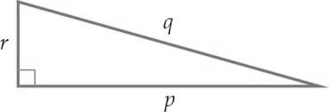

Which one is a true statement of Pythagoras’ theorem?

A *p*2 + *q*2 = *r*2 B *p*2 = *q*2 + *r*2  C  D *p*2 + *r*2 = *q*2

Question 2 [2.2]

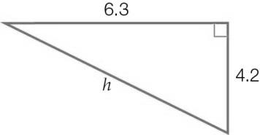

Which one of these equations could be used to find the length of the hypotenuse (*H*) in the right-angled triangle?

A *H*2 = 6.32 + 4.22 B *H*= 6.3 + 4.2 C *H*2 = 6.32 – 4.22 D *H* = 

Question 3 [2.3]

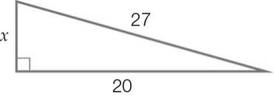

The hypotenuse of a right-angled triangle has a length of 27 units. The length of one of the shorter sides is 20 units. What is the exact value of the third side?

A  B  C  D 

Question 4 [2.4]

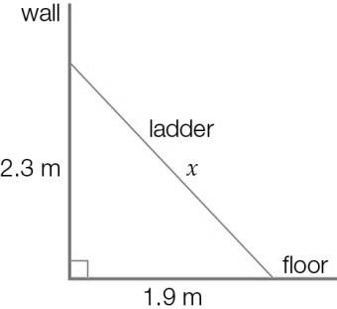

A ladder leans against a wall as shown in the diagram. Which one of the following statements is true?

A The top of the ladder is 2.3 m from the wall.

B The bottom of the ladder is 2.3 m from the wall.

C The top of the ladder is 2.3 m from the floor.

D The ladder is 4.2 m long.

Question 5 [2.5]

(9, 40, 41) is a Pythagorean triple.   
Which one of the following sets of numbers is also a Pythagorean triple?

A (10, 41, 42) B (19, 80, 82) C (27, 120, 123) D (90, 400, 420)

Question 6 [2.2]

If *h*2 = 3.82 + 9.32, find the value of *h* to 2 decimal places.

A 10.04 B 10.05 C 13.10 D 100.93

Multiple-choice results: ___ / 6

Short answer section

Question 7 3 marks [2.1, 2.2]

In a right-angled triangle, the hypotenuse is always longer/shorter than the other two sides.  
The right angle in a right-angled triangle is beside/opposite the hypotenuse.  
To find the length of the hypotenuse, the first step is to add the squares/square roots of the other two sides.

Question 8 2 marks [2.1]

Label the right angle and the hypotenuse in each right-angled triangle.

**(a) 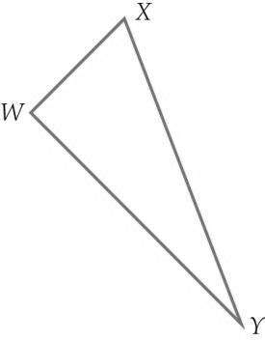 (b)** 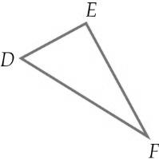

Question 9 1 mark [2.1]

Sketch a right-angled triangle with side lengths of 10 cm, 6 cm and 8 cm. Label the hypotenuse and the right angle.

Question 10 2 marks [2.2]

Tilly wants to check that a room is ‘square’. She measures the length and width of the floor of the room as 5.7 m and 4.2 m and the diagonal across the room as 7.2 m.

Use the converse of Pythagoras’ theorem to show that Tilly’s room is not ‘square’.

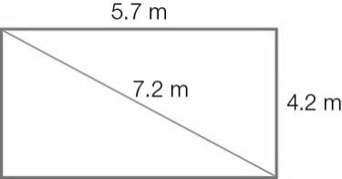

Question 11 6 marks [2.4]

Draw a labelled diagram for each situation.

**(a)** In a classroom, a one-metre (100 cm) ruler is leaning against the wall. The top of the ruler touches the wall 95 cm above the floor.

**(b)** There is a ramp between two levels in a shopping centre. The top of the ramp is 2.8 metres above the lower level. The ramp is 7.3 metres long.

**(c)** The top of a slide in a playground is 1.3 metres above the ground. The slide covers a horizontal distance of 3.9 metres**.**

Question 12 3 marks [2.2]

Find the length of the hypotenuse *q* in the following triangle, to 2 decimal places.

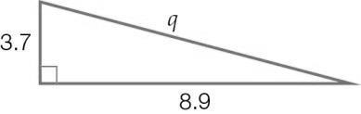

Question 13 2 marks [2.3]

Find the value of *a* in this right-angled triangle, to 2 decimal places.

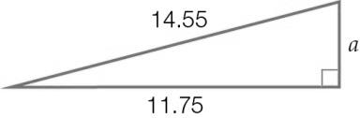

Question 14 2 marks [2.3]

Find the value of the pronumeral *m* in this right-angled triangle.   
Give your answer in exact (surd) form.

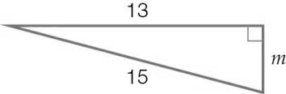

Question 15 3 marks [2.4]

Which one of these sets of numbers is a Pythagorean triple? (Show calculations for each set.)

Set 1: (20, 48, 51)

Set 2: (22, 120, 122)

Short answer results: ___ / 24

Extended answer section

Question 16 5 marks [2.1, 2.5]

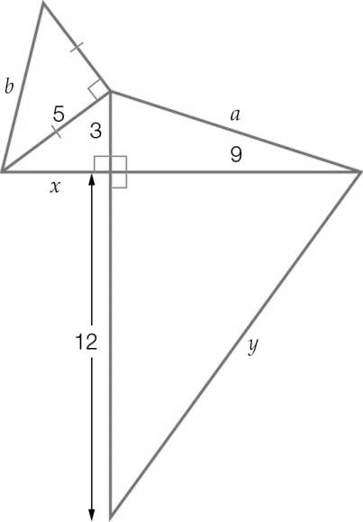

(a) Use Pythagorean triples to write the values of *x* and *y*.

(b) Write the equations you would use to find *a* and *b*. (Do not solve the equations.)

Question 17 5 marks [2.3, 2.4]

A flagpole is supported by two wires. Each wire is 18.5 metres long. They are attached to the flagpole at a point 17.5 metres above the ground.

The wires are pegged to the ground. The pegs and the base of the flagpole are in a straight line.

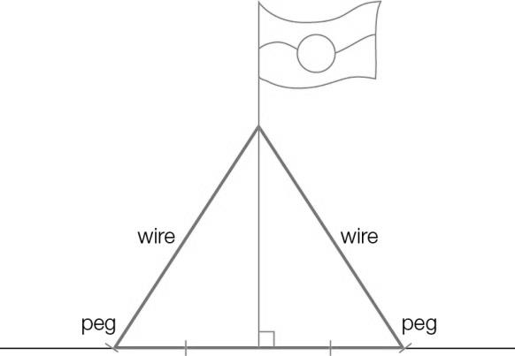

(a) Find the distance between the base of the flagpole and one of the pegs.

(b) How far apart are the pegs?

(c) The pegs are moved closer to the flagpole. If the pegs are now 4 metres from the base of the flagpole and the wires are still joined to the pole at the same place, what is the total length of wire needed? (Give your answer in metres correct to 2 decimal places.)

Question 18 6 marks [2.2, 2.4]

Erin walks from the train station (point *A*) to her house (point *B*). In this diagram of her walk, the lines on the grid are spaced 100 m apart.

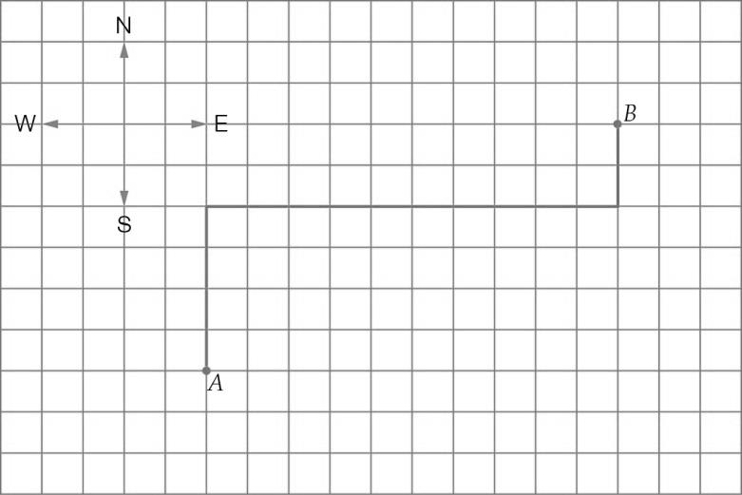

(a) Fill in the missing distances and directions in this description of Erin’s walk.

Erin walks ______ m north, then _____ m ____ and then 200 m ____.

(b) How many kilometres does Erin walk altogether?

(c) If Erin walks home from the train station in a straight line, how far does she have to walk? (If a straight line is drawn from point *A* to point *B*, what is the length of this line?) Give your answer rounded to the nearest metre.

Extended answer results: ___ / 16

TOTAL test results: ___ / 46